Public Transportation Efficiency Analysis

Phase 3 project

Start building the public transportation efficiency analysis using IBM Cognos for visualization.

Project Description:

The aims to conduct a comprehensive analysis of public transportation efficiency with a focus on
Sustainable development. This project will involve various research and development activities to
Improve the quality, accessibility, and sustainability of public transportation systems.

- Define Analysis Objectives:
Clearly define the objectives of your analysis. What aspects of public transportation efficiency are you trying to measure or improve? Common objectives include on-time performance, ridership trends, cost analysis, and route optimization.

- Data Collection:
Collect transportation data from the source shared with you. Ensure you have access to relevant data sources such as schedules, GPS data, maintenance records, and financial data.

- Data Processing and Cleaning:
To ensure data quality and accuracy, follow these steps:
- Data Integration: Combine data from various sources if necessary.
- Data Cleaning: Remove duplicates, handle missing values, and correct data entry errors.
- Data Transformation: Convert data into a format suitable for analysis.
- Data Validation: Verify data accuracy and consistency.

- Data Preparation:
Prepare the data for analysis by organizing it into suitable data models and structures. Define key metrics and dimensions that you will use in your analysis.

5.Data Visualization:
Use IBM Cognos to create visualizations that represent the analyzed data. You can create various types of charts, graphs, and dashboards to convey your findings.

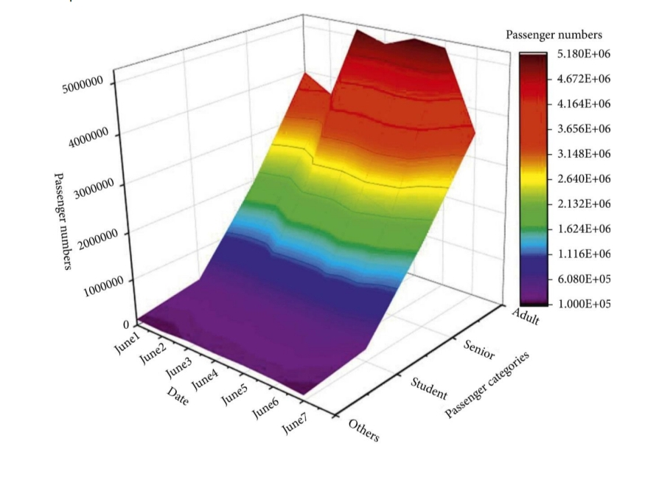
6.Analysis and Insights:
Analyze the data to derive insights related to your defined objectives. Compare different aspects of public transportation efficiency and identify areas that need improvement.

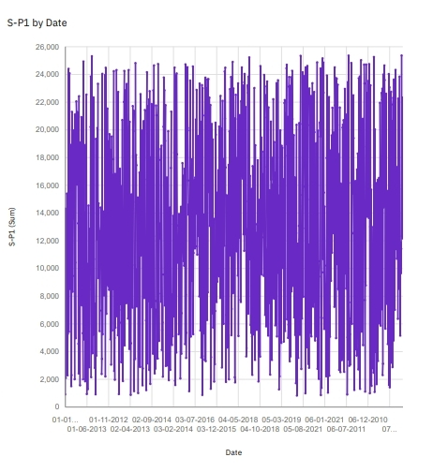

7.Report Generation: Create reports and presentations based on your analysis and insights. These reports can be used to communicate your findings to stakeholders.

8.continuous Monitoring:
Public transportation efficiency is an ongoing concern. Consider setting up automated reports in IBM Cognos to monitor key metrics regularly and identify trends or issues as they arise.

9.Action Plans:
Based on your analysis, develop action plans to address any inefficiencies or areas that require improvement in public transportation.

Expected outcomes:

- Improved public transportation efficiency.

- Reduced carbon emissions and environmental impact.

- Enhanced accessibility for all members of the community.

- Increased public awareness of the benefits of sustainable public transportation.

